# ABSTRACT

Customer Segmentation is the subdivision of a market into discrete customer groups that share similar characteristics. Customer Segmentation can be a powerful means to identify unsatisfied customer needs. Using the above data companies can then outperform the competition by developing uniquely appealing products and services.

The most common ways in which businesses segment their customer base are:

1. **Demographic information**, such as gender, age, familial and marital status, income, education, and occupation.
2. **Geographical information**, which differs depending on the scope of the company. For localized businesses, this info might pertain to specific towns or counties. For larger companies, it might mean a customer’s city, state, or even country of residence.
3. **Psychographics**, such as social class, lifestyle, and personality traits.
4. **Behavioral data**, such as spending and consumption habits, product/service usage, and desired benefits

# TABLE OF CONTENTS

1. **INTRODUCTION…………………………………….2**
2. **USE CASES……….……………………………………3**
3. **VISUALIZATION………………………………….......4-7**
4. **CODE…………………………………………………...7**
5. **CONCLUSION ………………………………………..8**

## INTRODUCTION

## Why Segment Customers?

Segmentation allows marketers to better tailor their marketing efforts to various audience subsets. Those efforts can relate to both communications and product development. Specifically, segmentation helps a company:

* Create and communicate targeted marketing messages that will resonate with specific groups of customers, but not with others (who will receive messages tailored to their needs and interests, instead).
* Select the best communication channel for the segment, which might be email, social media posts, radio advertising, or another approach, depending on the segment.
* Identify ways to improve products or new product or service opportunities.
* Establish better customer relationships.
* Test pricing options.
* Focus on the most profitable customers.
* Improve customer service.
* Upsell and cross-sell other products and services.

## How to Segment Customers

Customer segmentation requires a company to gather specific information – data – about customers and analyze it to identify patterns that can be used to create segments.

Some of that can be gathered from purchasing information – job title, geography, products purchased, for example. Some of it might be gleaned from how the customer entered your system. An online marketer working from an opt-in email list might segment marketing messages according to the opt-in offer that attracted the customer, for example. Other information, however, including consumer demographics such as age and marital status, will need to be acquired in other ways.

## USE CASES

## Using Customer Segments

Common characteristics in customer segments can guide how a company markets to individual segments and what products or services it promotes to them. A small business selling hand-made guitars, for example, might decide to promote lower-priced products to younger guitarists and higher-priced premium guitars to older musicians based on segment knowledge that tells them that younger musicians have less disposable income than their older counterparts. Similarly, a meals-by-mail service might emphasize convenience to millennial customers and “tastes-like-mother-used-to-make” benefits to baby boomers.

Customer segmentation can be practiced by all businesses regardless of size or industry and whether they sell online or in person. It begins with gathering and analysing data and ends with acting on the information gathered in a way that is appropriate and effective.

Typical information-gathering methods include:

* Face-to-face or telephone interviews
* Surveys
* General research using published information about market categories
* Focus groups

## Customer Segmentation Analysis Best Practices

So how do you go about dividing your user base in a way that helps you achieve key business goals? Follow these rules of thumb for an effective customer segmentation strategy.

1. **Know your users.** What acquisition channels do they come from? Why and how do they use your app? How does your solution solve their pain points? Learn as much as you can about your current customer base and their app usage habits.
2. **Don’t get too specific.** Communications expert Frank Luby advises his “[three-adjective rule](https://www.linkedin.com/pulse/20141030142318-539588-5-tips-on-market-segmentation/)”: if you can’t describe your segment in three adjectives, it’s too complicated. Segments like “users who follow ‘80s rock playlists” are more actionable than “users who listened to ‘Bohemian Rhapsody’ in the last 24 hours.” After all, segments need to be big enough that targeting them is worth the effort.

**VISUALIZATION**

**TABLE VISUALIZATION:**

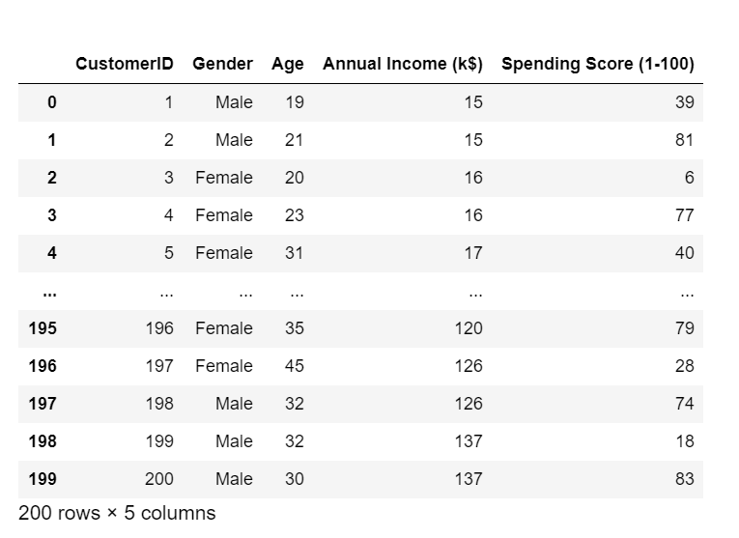

**MALE/FEMALE SPENDING SCORE**:

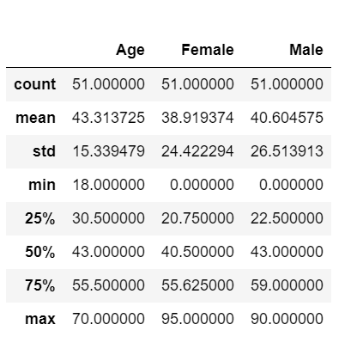

**BARPLOT INCOME VS GENDER:**

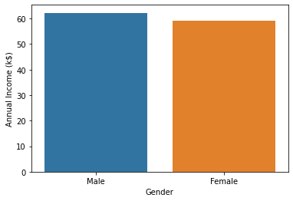

**BARPLOT SCORE VS GENDER:**

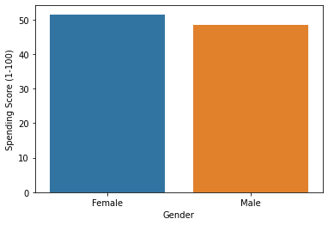

**BARPLOT EXTENDED:**

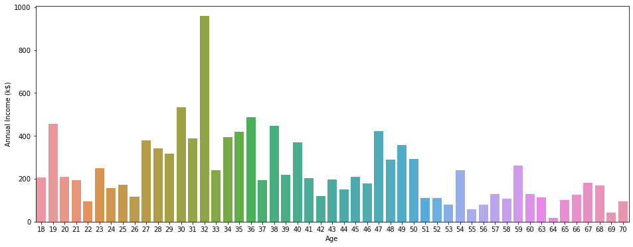

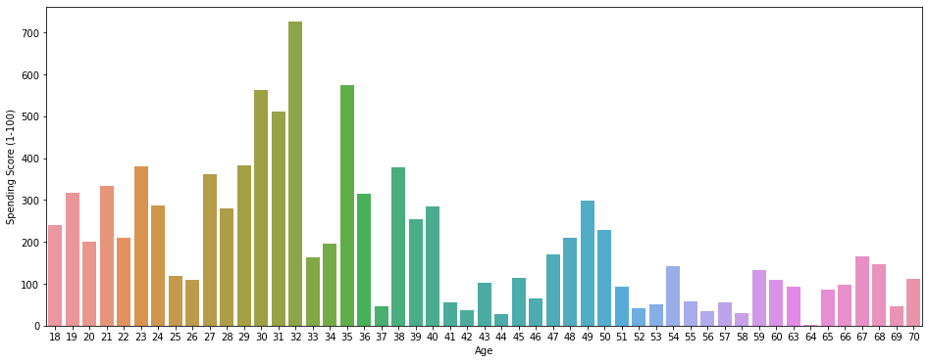

**SCATTER PLOT:**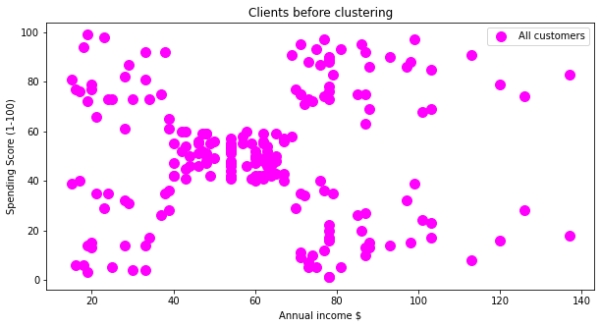

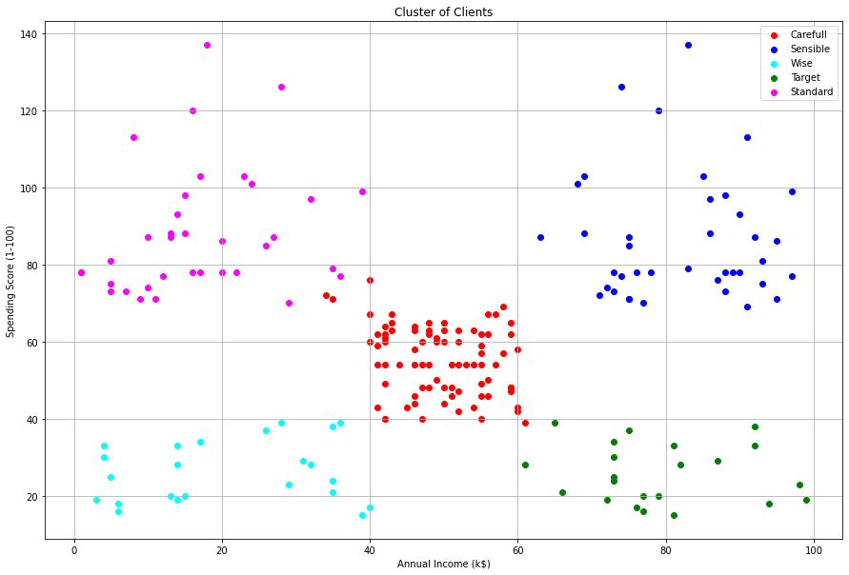

**CODE**

**X = df.iloc[:, [3, 4]].values**

**fig = plt.figure(figsize = (10,5))**

**plt.scatter(X[:,0],X[:,1],s=100,c='magenta',label='All customers')**

**plt.title('Clients before clustering')**

**plt.xlabel('Annual income $')**

**plt.ylabel('Spending Score (1-100)')**

**plt.show()**

**from sklearn.cluster import KMeans**

**history_inertia = list()**

**columns_cluster = [ [ "Spending Score (1-100)","Annual Income (k$)"]]**

**for i in range(2, 15):**

**model = KMeans(n_clusters=i, random_state=10, n_jobs=-1)**

**model.fit(df[columns_cluster[0]])**

**history_inertia.append(model.inertia_)**

**plt.figure(figsize=(10,7))**

**plt.plot(np.arange(2,15), history_inertia)**

**plt.show()**

**plt.figure(figsize=(15,10))**

**model = KMeans(n_clusters=5, random_state=10)**

**y_hat = model.fit_predict(df[columns_cluster[0]])**

**labels = ["Carefull", "Standard", "Wise",**

**"Sensible", "Target"]**

**plt.scatter(df[y_hat == 0][columns_cluster[0][0]], df[y_hat == 0][columns_cluster[0][1]],c='red',label=labels[0])**

**plt.scatter(df[y_hat == 1][columns_cluster[0][0]], df[y_hat == 1][columns_cluster[0][1]],c='blue',label=labels[3])**

**plt.scatter(df[y_hat == 2][columns_cluster[0][0]], df[y_hat == 2][columns_cluster[0][1]],c='cyan',label=labels[2])**

**plt.scatter(df[y_hat == 3][columns_cluster[0][0]], df[y_hat == 3][columns_cluster[0][1]],c='green',label=labels[4])**

**plt.scatter(df[y_hat == 4][columns_cluster[0][0]], df[y_hat == 4][columns_cluster[0][1]],c='magenta',label=labels[1])**

**plt.legend()**

**plt.grid()**

**plt.title('Cluster of Clients')**

**plt.xlabel(columns_cluster[0][1])**

**plt.ylabel(columns_cluster[0][0])**

**CONCLUSION**

We can see that the mall customers can be broadly grouped into 5 groups based on their purchases made in the mall.

In cluster(Cyan colored) we can see people have low annual income and low spending scores, this is quite reasonable as people having low salaries prefer to buy less, in fact, these are the wise people who know how to spend and save money.The shops/mall will be least interested in people belonging to this cluster.

In cluster(Magenta colored) we can see that people have low income but higher spending scores, these are those people who for some reason love to buy products more often even though they have a low income.Maybe it’s because these people are more than satisfied with the mall services.The shops/malls might not target these people that effectively but still will not lose them.

In cluster(red colored) we see that people have average income and an average spending score, these people again will not be the prime targets of the shops or mall, but again they will be considered and other data analysis techniques may be used to increase their spending score.

In cluster(Blue-colored) we see that people have high income and high spending scores,this is the ideal case for the mall or shops as these people are the prime sources of profit. These people might be the regular customers of the mall and are convinced by the mall’s facilities.

In cluster(green colored) we see that people have high income but low spending scores,this is interesting. Maybe these are the people who are unsatisfied or unhappy by the mall’s services.

These can be the prime targets of the mall, as they have the potential to spend money.

So, the mall authorities will try to add new facilities so that they can attract these people and can meet their needs.

THE END.